Screenshots of the output of ML models; LDA, NN-MLP, RF, in the assignment deployed through Docker.

1: LDA

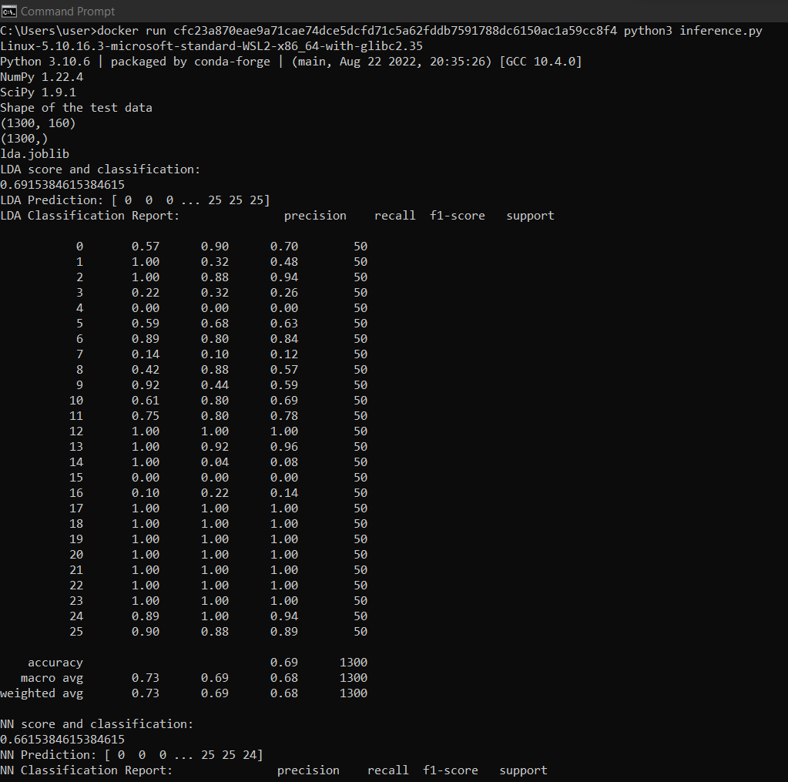

2. NN - MLP

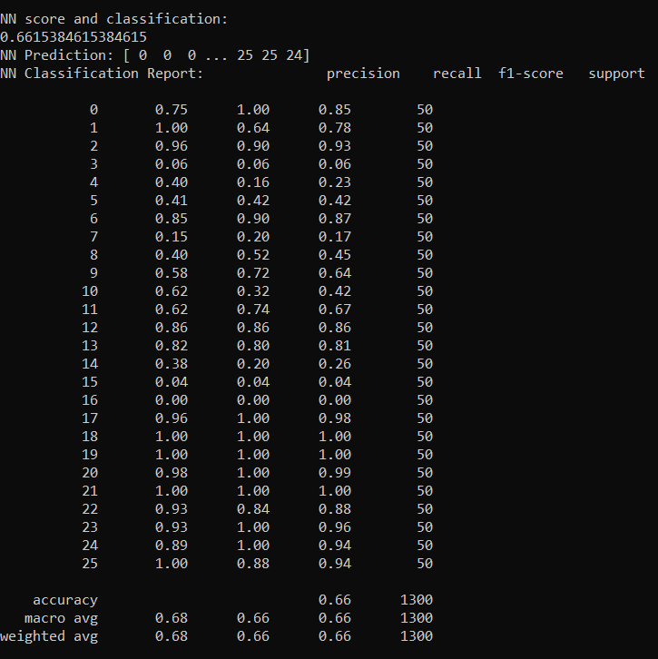

3. RF

